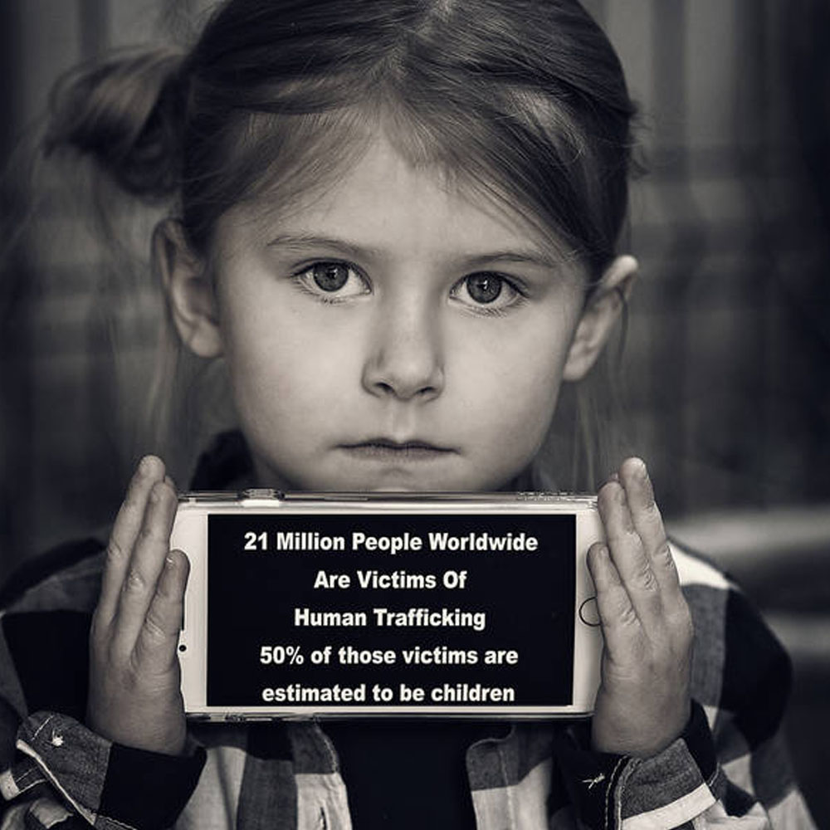

Missing People Database Management System

IST 659 Project Implementation Report

Report prepared by Laxman Kumar and Sarthak Tandon

INDEX

Contents

I. Project Summary 3

II. Entity and Attribute table 4

1. Registered User table 4

2. Police Department table 4

3. Police Designation Information table 5

4. Police Information master 5

5. Complaint table 5

6. Missing person information table 6

III. Entity Relation Diagram 7

IV. Database System Architecture 8

V. SQL Scripts 8

1. Creating tables 8

2. Inserting values 11

VI. Major Data Questions 16

VII. Interface 19

1. Forms 19

2. Hybrid Mobile App 27

3. Reports 29

# Project Summary

This project focuses on designing a data base system for the Indian Police to keep track of the Data for Unidentified and Missing persons. India has a very high volume of child trafficking and missing people. Thousands of people go missing and more than thousands of people are untraced and unidentified. With the high volume of missing people and child trafficking, India still lacks a system to track and identify missing people. There are thousands of beggars on the street and thousands of girls working as sex slave, but the law enforcement has failed to track and identify. India clearly needs a centralized system for managing and tracking missing people and trying to identify the unidentified people roaming and begging for food on the streets. There is no system available or dataset which can be used to trace people. The only data available is in the form of First Information Report (F.I.R.) which is filed by the law enforcement during the complain of the missing people and that information also lacks digitalized format. Building a common system for law and people is the feasible solution.

A root cause of child trafficking in India is due to poverty, need to support family which cause child labor and lack of education. Missing and abducted children are forced to beg on the street and missing girls are forced to trade herself for sex. Trafficking of young girls (under age of 18) has grown 14 times over the last decade and grown by 65% just in the year 2014 according to the National Crime Record Bureau. According to the US State Department, there are approximately 600,000 to 820,000 people trafficked a year across international borders, and up to 50% of those are children. In India specifically, it is estimated that there are around 135,000 children trafficked each year.

The following system will be used to keep track of the Data for Unidentified and Missing persons. The system will bridge the gap between the populous and the authorities and will promote transparency. People can file the complaint and keep track of the same and the responsible authorities can use the same data to carry out their investigation and close the case on time. Since the investigation’s findings will be public, this will add the required pressure and urgency on the authority’s side to solve and close the case. The data base will also digitize the process of filing complaint and improve the data storage, getting rid of any delays from the authorities and red tapism, which exists in the present organizations. It will also eliminate any human error which exists when filling reports and allotting cases.

The process will be as follows:

1. A user is registered in the data base

2. The Registered used files a missing person report with the required information needed to identify the individual

3. Once the FIR is generated, a Police department is assigned the case which then assign a case to the Police office

# Entity and Attribute table

## Registered User table

|  |  |
| --- | --- |
| RegisteredUser |  |
| UID | User id generated by system – Primary Key |
| FName | First name of the user |
| LName | Last name of the user |
| AddressLine1 | Address line 1 of the user |
| AddressLine2 | Address line 2 of the user |
| City | Name of the city |
| State | Name of the state |
| Pincode | Pincode/Zipcode of the user |
| AadharCard | Addhar card number of the user. A form government identification number. |
| PrimaryNumber | Primary contact number |
| SecondaryNumber | Secondary contact number |
| EmailID | Email address of the user |

The table will content the data of the registered user. Registration is mandatory if a person wants to file a complain of missing person. While registration user must provide the government identification number which will prove the authenticity of the registered user and the complained filed.

## Police Department table

This table will contain data of all the police department in the country. Department can be head office, police station or any district office.

|  |  |
| --- | --- |
| PoliceDepartment |  |
| PDID | Department id – Primary key |
| DepartmentName | Name of the police department. |
| DAddressLine1 | Address line 1 of the department |
| DAddressLine2 | Address line 2 of the department |
| DCity | Department City |
| DState | Department State |
| Pincode | Pincode/Zipcode of the department. |
| DepartmentHead | Head of the department |

## Police Designation Information table

This table will contain all the police designations available in the country with the designation name and their description.

|  |  |
| --- | --- |
| PoliceDesginationInformation |  |
| PDesID | Designation id – Primary Key |
| PositionName | Name of the position |
| PositionDescription | Description |
| Postion Abbreviation | Abbreviation of the position |

## Police Information master

|  |  |
| --- | --- |
| PoliceInformation |  |
| PID | Police identification number/batch number |
| FName | First name of the police |
| LName | Last name of the police |
| PAddressLine1 | Address line 1 of the police |
| PAddressLine2 | Address line 2 of the police |
| PCity | City of the police |
| PState | State of the police |
| Pincode | Pincode/Zipcode of the police |
| PrimaryNumber | Primary number of the police |
| EmailID | Email id of the police |
| PoliceDepartmentInfo | Department place – Foreign key |
| PolicePositionInfo | Current Position – Foreign Key |

Police Information master will have detail of all the active police officers in the country ranging from Head of the Police Department of India to police officer.

## Complaint table

This table will contain the filed complained with the FIR number. Table will have all the information about who filed the complaint, police officer assigned, in which department complaint was registered.

|  |  |
| --- | --- |
| ComplainedMaster |  |
| ComplainedID | Autogenerated id of the complained filed  Primary Key and Foreign Key |
| MissingPersonID | Missing person id |
| FIRGeneratedID | FIR number generated by police department |
| PoliceID | Police id who filed the complaint and fir |
| PoliceStationID | Police station id where the complaint is registered |
| CaseClosedDate | Date on which the case was closed |
| IsSolved | Is the case is solved or not – default False |
| CaseClosingDescription | Detail and reason of closing the case |

## Missing person information table

This table will contain every single detail of the person missing. His/her name, age, sex, last seen location and date time, special identification marks and other details. The person filing the complain will also have to specify the relation to the missing person.

|  |  |
| --- | --- |
| MissingPersonInformation |  |
| ComplaintID | Missing person complaint id generated by system – Primary Key |
| MFirstName | First name |
| MLastName | Last name |
| Age | Age of the missing person |
| Gender | Sex of the missing person |
| AddressLine1 | Address line 1 of the user |
| AddressLine2 | Address line 2 of the user |
| City | Name of the city |
| State | Name of the state |
| Pincode | Pincode/Zipcode of the user |
| PrimaryNumber | Primary number of the Missing Police |
| LastSeenAddress1 | Last location of the missing person |
| LastSeenAddress1 | Last location of the missing person |
| LastSeenDateTime | Last seen date and time |
| EyeColor | Color of the eye |
| Height | Height of the missing person |
| Weight | Weight of the missing person |
| ClothesDescription | Description of the clothes |
| SkinColor | Color of the skin |
| ComplainedFiledBy | Complained filed by – Foreign Key to RegisterdUser table |
| Photo | Photo of the missing person |
| Relation | Relation to the person who filed the complain |
| Description | Identification marks and other description |
| UID | ID of the Registered User – Foreign Key |

# Entity Relation Diagram

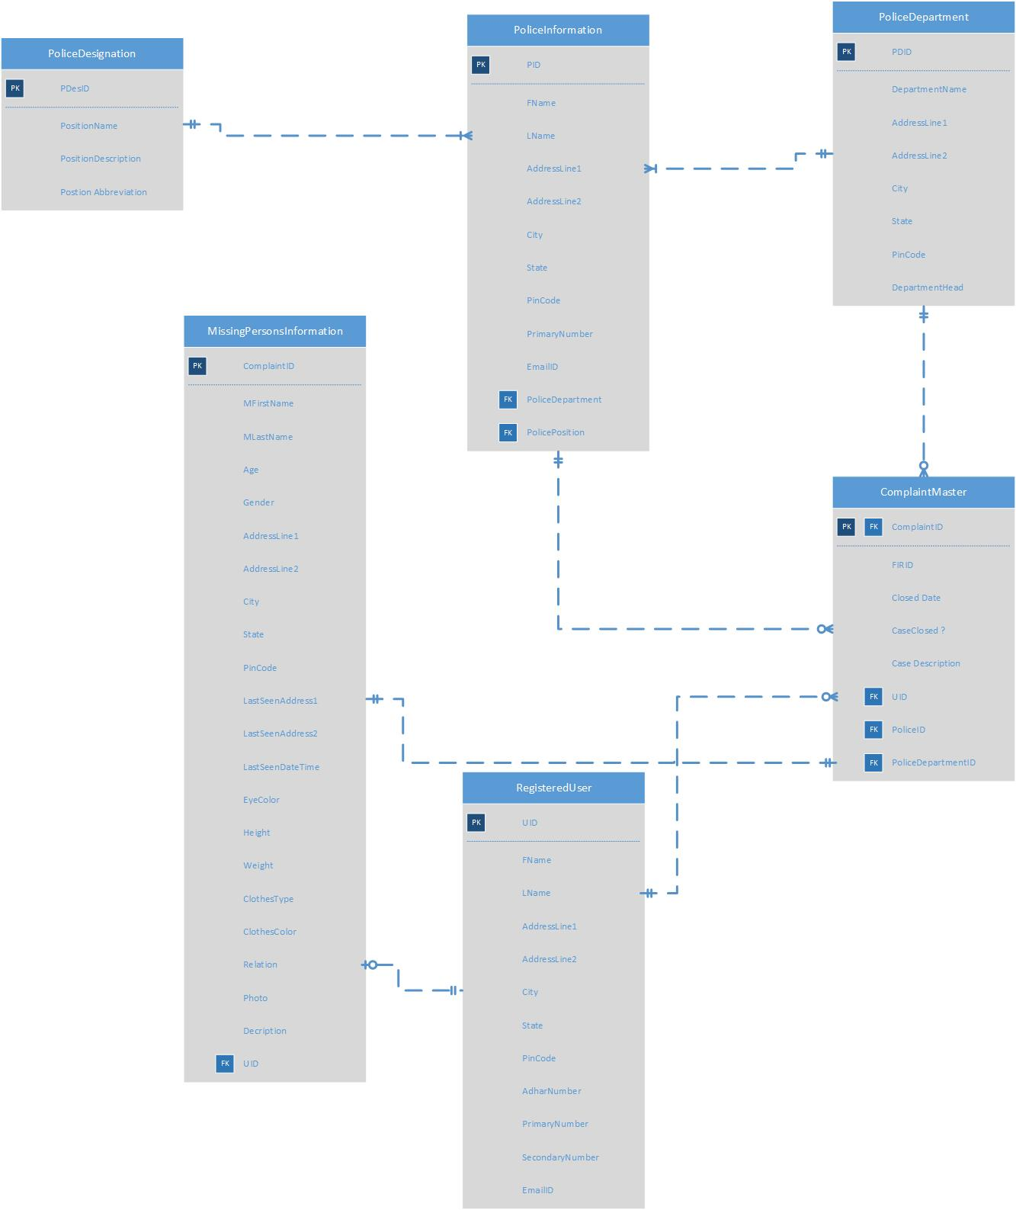

# Database System Architecture

We used the following tools design the course of this project:

* **Microsoft Visio:** MS Visio was used to create the entity relation diagram for the project and conceptualize the attributes and relations of the different entities.
* **Microsoft Access:** MS Access was used to create the interface of the project system. We created forms which displayed necessary data to the user. We also used Access to generate reports
* **Microsoft SQL Server:** MS SQL server was used to create the database of the project. We wrote queries to make the various tables and inserted data using SQL. We also created views to using the same.
* **Flutter:** Flutter was used to make the mobile interface for the project system. Users can register themselves and generate complaints using their mobile devices or tablets.

# SQL Scripts

## Creating tables

**Table : Police Designation**

create table PoliceDesignation

(

PDesID Char (10) primary key,

PositionName VarChar(20) not null,

PositionDesc VarChar(40) not null,

PositionAbbr Char (4) not null

);

**Table : Police Department**

create table PoliceDepartment

(

PDID Char (10) primary key,

DepartmentName VarChar(20) not null,

AddrLine1 VarChar(30) not null,

AddrLine2 VarChar(30),

City VarChar(20) not null,

State VarChar(20) not null,

Pincode Char (6) not null,

DepartmentHead VarChar(20) not null

);

**Table : Police Information**

create table PoliceInfo

(

PID Char (10) primary key,

FName VarChar(20) not null,

LName VarChar(20) not null,

AddrLine1 VarChar(30) not null,

AddrLine2 VarChar(30) not null,

City VarChar(20) not null,

State VarChar(20) not null,

Pincode Char (6) not null,

PrimaryNumber Char (10) not null,

EmailID VarChar(30) not null,

PoliceDepartment Char (10) not null,

PoliceDesignation Char (10) not null,

constraint dept_FK FOREIGN KEY (PoliceDepartment) REFERENCES PoliceDepartment(PDID),

constraint des_FK FOREIGN KEY (PoliceDesignation) REFERENCES PoliceDesignation(PDesID)

);

**Table : Registered User**

create table RegisteredUser

(

UID Char (10) primary key,

FName VarChar(20) not null,

LName VarChar(20) not null,

AddrLine1 VarChar(30) not null,

AddrLine2 VarChar(30),

City VarChar(20) not null,

State VarChar(20) not null,

Pincode Char (6) not null,

AdharNumber Char (12) not null,

PrimaryNumber Char (10) not null,

SecondaryNumber Char (10),

EmailID VarChar(30) not null

);

**Table : Missing Person Information**

create table MissingPersonInfo

(

ComplaintID Char (10) primary key,

FName VarChar(20) not null,

LName VarChar(20) not null,

Age tinyint,

Gender Char (1) not null,

AddrLine1 VarChar(30) not null,

AddrLine2 VarChar(30),

City VarChar(20) not null,

State VarChar(20) not null,

Pincode Char (6) not null,

LastSeenAddrLine1 VarChar(30) not null,

LastSeenAddrLine2 VarChar(30),

LastSeenDateTime datetime,

EyeColor VarChar(10),

Height tinyint,

Weight tinyint,

ClothesDescription VarChar(100),

SkinColor VarChar(10),

Relation VarChar(10),

Photo blob,

Description VarChar(40),

UID Char (10) not null,

constraint ru_FK FOREIGN KEY (UID) REFERENCES RegisteredUser(UID)

);

**Table : Complaint Master**

create table ComplaintMaster

(

ComplaintID Char (10) primary key,

FIRID Char (10) not null,

ClosedDate date,

CaseClosed bit not null,

CaseDesc VarChar(50) not null,

UID Char (10) not null,

PoliceID Char (10) not null,

PoliceDeptID Char (10) not null,

constraint rucm_FK FOREIGN KEY (ComplaintID) REFERENCES MissingPersonInfo(ComplaintID),

constraint rucm_FK FOREIGN KEY (UID) REFERENCES RegisteredUser(UID),

constraint deptcm_FK FOREIGN KEY (PoliceDeptID) REFERENCES PoliceDepartment(PDID),

constraint pcm_FK FOREIGN KEY (PoliceID) REFERENCES PoliceInfo(PID)

);

## Inserting values

**Table : Police Designation**

INSERT INTO `policedesignation` (`PDesID`, `PositionName`, `PositionDesc`, `PositionAbbr`) VALUES

('1', 'Director General', 'Director General of Police', 'DGP'),

('2', 'Commissioner', 'Commissioner of Police', 'CP'),

('3', 'Deputy Commissioner', 'Deputy Commissioner of Police', 'DCP'),

('4', 'Asst Commissioner', 'Assitant Commissioner of Police', 'ACP'),

('5', 'Inspector', 'Inspector', 'I');

**Table : Police Department**

INSERT INTO `policedepartment` (`PDID`, `DepartmentName`, `AddrLine1`, `AddrLine2`, `City`, `State`, `Pincode`, `DepartmentHead`) VALUES

('1', 'Mumbai Police', 'D.N. RoadFort', NULL, 'Mumbai', 'Maharashtra', '400001', 'Sanjay Barve'),

('2', 'Chennai Police', 'EVK SAMPATH ROAD, VEPERY', NULL, 'Chennai', 'Tamil Nadu', '600007', 'Dr AK Viswanathan'),

('3', 'Delhi Police', 'Jai Singh Road', NULL, 'Delhi', 'New Delhi', '110002', 'Amulya Patnaik'),

('4', 'Bangalore Police', 'No. 1 Infantry Road', NULL, 'Bangalore', 'Karnataka', '560001', 'Bhaskar Rao'),

('5', 'Kolkata Police', '18, Lalbazar Street', NULL, 'Kolkata', 'West Bengal', '700001', 'Anuj Sharma'),

('6', 'Pune Police', '2, Sadhu Vaswani Road, Camp', NULL, 'Pune', 'Maharashtra', '411001', 'Dr. K Venkatesham'),

('7', 'Rajasthan Police', 'Lalkothi', NULL, 'Jaipur', 'Rajasthan', '302015', 'Dr. Bhupendra Singh'),

('8', 'Lucknow Police', '2, Under Cantt Flyover', 'Cantt Flyover,', 'Lucknow', 'Uttar Pradesh', '226002', 'Kala Nidhi Naithani');

**Table : Police Infromation**

INSERT INTO `policeinfo` (`PID`, `FName`, `LName`, `AddrLine1`, `AddrLine2`, `City`, `State`, `Pincode`, `PrimaryNumber`, `EmailID`, `PoliceDepartment`, `PoliceDesignation`) VALUES

('1', 'Laxman', 'Kumar', 'HPCL Officers Appartment', 'BKC', 'Mumbai', 'Maharashtra', '400051', '8754526547', 'laku@gmail.com', '1', '4'),

('2', 'Bhavish', 'Kumar', 'Parathe Wale Gali', 'Chandini Chok', 'Delhi', 'New Delhi', '110006', '1234567890', 'bhaku@gmail.com', '3', '4'),

('3', 'Prankur', 'Garg', 'Florentine', 'Sopan Baug', 'Pune', 'Maharashtra', '410038', '9874653210', 'prgarg@hotmail.com', '6', '3'),

('4', 'Pranav', 'Radha', '524, Grukripa', 'Kasturi nagar', 'Bangalore', 'Karnataka', '560054', '8939109415', 'pranav.r@gmail.com', '4', '4'),

('5', 'Dhrumil', 'Shah', 'Bhavanipur', NULL, 'Kolkata', 'WestBengal', '700020', '4563218971', 'dshah@gmail.com', '5', '5'),

('6', 'Shreya', 'Dixit', '6, Malviya Nagar', 'Opp VR', 'Jaipur', 'Rajasthan', '302006', '1234567890', 's.dixit@gmail.com', '7', '4'),

('7', 'Zainab', 'Merchant', 'Nirala Nagar', 'Near Anjuman Hosp', 'Lucknow', 'Uttar Pradesh', '226015', '9874653210', 'zainab.merch@yahoo.com', '8', '5'),

('8', 'Roshnee', 'Sundaraman', '1/24 G.S.T Road', NULL, 'Chennai', 'Tamil Nadu', '600027', '8939109415', 'roshnee@gmail.com', '2', '4'),

('9', 'Shubham', 'Shukla', '216/1', 'HSR Road', 'Bangalore', 'Karnataka', '560054', '4563218971', 'shukla1980@gmail.com', '4', '5'),

('10', 'Naveen ', 'Bagga', '1-55 F Near Jaipuria School', 'Vineet Khand, Gomtinagar', 'Lucknow', 'Uttar Pradesh', '226010', '1234567890', 'naveen1967@hotmail.com', '8', '5');

**Table : Registered User**

INSERT INTO `registereduser` (`UID`, `FName`, `LName`, `AddrLine1`, `AddrLine2`, `City`, `State`, `Pincode`, `AdharNumber`, `PrimaryNumber`, `SecondaryNumber`, `EmailID`) VALUES

('1', 'Sarthak', 'Tandon', '216', 'HPCL Appr', 'Mumbai', 'Maharahstra', '400051', '98754123011', '1234567890', '', 'srtrockz@gmail.com'),

('2', 'Mukesh', 'Kumar', 'B-116, Gali No.12', 'Johripur', 'Delhi', 'New Delhi', '700020', '12345678910', '9874653210', '', 'mukesh.ku@hotmail.com'),

('3', 'Kamal', 'Kishore', 'C-18, Galino.16', 'Matawaligali', 'Lucknow', 'Uttar Pradesh', '302006', '87456123950', '8939109415', '', 'kishore.1965@gmail.com'),

('4', 'Anil', 'Vohra', 'E 48/A25, Jhuggi Indira', 'Nehru Camp', 'Jaipur', 'Rajasthan', '226015', '23456879104', '4563218971', '', 'avohra@yahoo.com'),

('5', 'Rajesh', 'Thapar', '64 Tagore Garden', '', 'Chennai', 'Tamil Nadu', '600027', '56123478908', '1234567890', '', 'rajesh.t.1967@gmail.com'),

('6', 'Vijay', 'Kumar', '73 Rama Market', 'Pritam Village', 'Bangalore', 'Karnataka', '560054', '45698712358', '9874653210', '', 'v.kumar.2019@gmail.com'),

('7', 'Nirmal', 'Singh', 'A2/198, Amar Colony', '', 'Kolkata', 'West Bengal', '226010', '20587419637', '8939109415', '', 'singh.n@gmail.com'),

('8', 'Neetu', 'Malik', 'No. 29, Taimoor Nagar Village ', 'New Friends Colony', 'Pune', 'Maharahstra', '410081', '74185296332', '9854632178', '', 'malik.neetu@gmail.com'),

('9', 'Shabana', 'Begam', 'L-32, Loha Market', 'Welcome', 'Delhi', 'New Delhi', '110032', '85236915965', '8756321498', '', 'begam.s.187@gmail.com'),

('10', 'Lalbabu', 'Devi', 'C-82, Ambedkar Basti', '', 'Chennai', 'Tamil Nadu', '600055', '12365498795', '9654123987', '', 'deviji@yahoo.co.in'),

('11', ' Hari ', 'Shankar', 'No 7, Gautam Nagar', 'Hauz Khas', 'Chennai', 'Tamil Nadu', '600161', '36985201478', '6398741250', '', 'hari.s@yahoo.com'),

('12', 'Shyam', 'Gupta', 'G-437, Inder Enclave', 'Aman Vihar', 'Delhi', 'New Delhi', '110090', '57951984265', '8974156320', '', 'shyamgup@gmail.com'),

('13', 'Anamika', 'Das', 'F Block, Sundar Nagri', 'Kasturi Nagar', 'Bangalore', 'Karnataka', '560181', '14569654420', '7012365491', '', 'a.d.1984@gmail.com'),

('14', 'Arun', 'Chaudhary', '409, Ekta Vihar', '', 'Lucknow', 'Uttar Pradesh', '302011', '93698741250', '9632587416', '', 'arum1532@gmail.com');

**Table : Missing Person Information**

INSERT INTO `missingpersoninfo` (`ComplaintID`, `FName`, `LName`, `Age`, `Gender`, `AddrLine1`, `AddrLine2`, `City`, `State`, `Pincode`, `LastSeenAddrLine1`, `LastSeenAddrLine2`, `EyeColor`, `Height`, `Weight`, `Relation`, `Photo`, `Description`, `UID`, `primarynumber`, `ClothesDescription`, `SkinColor`, `LastSeenDateTime`) VALUES

('1', 'Hitesh', 'Kumar', 21, 'M', 'T-213, Gali No 1', 'Shivaji Nagar', 'Delhi', 'New Delhi', '110006', 'B-1248, J.J Colony Bawana', '', 'Blue', 6, 60, 'Nephew', 0x3235, '', '6', '4563218971', 'Yellow Shirt and Blue Jeans', 'L Brown', '2013-09-27 00:00:00'),

('2', 'Reeta', 'Singh', 10, 'F', 'H.No-6 /407', 'Trilok Puri', 'Kolkata', 'West Bengal', '226010', 'S- 15/84 J.J Camp ', '', '', 4, 45, 'Daughter', '', 'Last seen playing in the Park', '7', '', '', 'White', '2018-11-23 00:00:00'),

('3', 'Deepak', 'Vohra', 50, 'M', 'Flat No-386,', 'Sanskriti Apartment', 'Jaipur', 'Rajasthan', '226015', 'Flat No-386', 'Sanskriti Apartment', 'Brown', 6, NULL, 'Brother', '', 'Last seen taking a cab to a party', '4', '8939109415', 'Red Kurta and Jeans', 'L Brown', '2015-01-06 00:00:00'),

('4', 'Guddu', 'Thapar', 18, 'M', 'D-565', 'West Vinod Nagar', 'Chennai', 'Tamil Nadu', '600027', 'E-2/149, Nand Nagri ', '', '', 5, 82, 'Son', '', '', '5', '4563218971', '', 'Brown', '2019-10-23 00:00:00'),

('5', 'Ram', 'Tandon', 67, 'M', '216', 'HPCL Appr', 'Mumbai', 'Maharahstra', '400051', '', '', 'Grey', NULL, 60, 'Father', '', '', '1', '', '', 'L Brown', NULL),

('6', 'Alok', 'Kumar', 18, 'M', 'No. 29, Taimoor Nagar Village', 'New Friends Colony', 'Delhi', 'New Delhi', '110020', 'A-459 New Ashok Nagar', '', '', 5, 50, 'Son', '', '', '3', '', '', 'White', NULL),

('7', 'Bhagat', 'Kishore', 25, 'M', 'L-32, Loha Market', 'Welcome', 'Lucknow', 'Uttar Pradesh', '302006', 'BH-421, East Shalimar Bagh', '', '', NULL, 70, 'Brother', '', '', '7', '', '', 'L Brown', NULL),

('8', 'Anu', 'Malik', 44, 'M', 'C-82, Ambedkar Basti', '', 'Pune', 'Maharahstra', '410081', 'No. A1/374, Anand Nagri ', '', 'Brown', NULL, 60, 'Brother', '', '', '8', '', '', 'L Brown', NULL),

('9', 'Fatima', 'Begam', 27, 'F', 'No 7, Gautam Nagar', 'Hauz Khas', 'Delhi', 'New Delhi', '110032', '1/24 G.S.T Road', '', '', 5, NULL, 'Daughter', '', '', '9', '', '', 'L Brown', NULL),

('10', 'Prabha', 'Devi', 69, 'F', 'G-437, Inder Enclave', 'Aman Vihar', 'Chennai', 'Tamil Nadu', '600055', '216/1', '', 'Blue', 5, NULL, 'Mother', '', '', '10', '', '', 'White', NULL),

('11', 'Shiv', 'Shankar', 32, 'M', 'Connaught Circus ', 'Kasturi Nagar', 'Chennai', 'Tamil Nadu', '600161', '1-55 F Near Jaipuria School', '', '', 6, NULL, 'Brother', '', '', '11', '', '', 'L Brown', NULL),

('12', 'Sanket', 'Gupta', 15, 'M', 'C-36 Gulomohar Park', '', 'Delhi', 'New Delhi', '110090', 'Florentine', 'Sopan Baug', 'Brown', 4, NULL, 'Son', '', '', '12', '', '', 'L Brown', '2017-04-01 00:00:00'),

('13', 'Ahesh', 'Narayan', 23, 'M', '', '', 'Bangalore', 'Karnataka', '560181', 'F Block, Sundar Nagri', 'Kasturi Nagar', '', 5, NULL, 'Friend', '', '', '13', '', '', 'Brown', NULL),

('14', 'Priya', 'Bhasin', 19, 'F', '', '', 'Lucknow', 'Uttar Pradesh', '302011', '409, Ekta Vihar', '', 'Grey', 6, NULL, 'Friend', '', '', '14', '', '', 'Brown', '2019-05-26 00:00:00');

**Table : Complaint Master**

INSERT INTO `complaintmaster` (`ComplaintID`, `FIRID`, `ClosedDate`, `CaseClosed`, `CaseDesc`, `UID`, `PoliceID`, `PoliceDeptID`) VALUES

('1', '2013001', NULL, b'0', 'No Developments Yet', '6', '2', '3'),

('2', '2018052', '2018-12-04', b'1', 'Person found in two weeks in a town near Mohali', '7', '5', '5'),

('3', '20151121', NULL, b'0', 'No Developments Yet', '4', '6', '7'),

('4', '2019009', NULL, b'0', 'No Developments Yet', '5', '8', '2'),

('5', '2016121', '2016-06-30', b'1', 'Victim was killed in a highway accident', '1', '1', '1'),

('6', '2017282', NULL, b'0', 'No Developments Yet', '3', '2', '3'),

('7', '2019565', NULL, b'0', 'No Developments Yet', '7', '7', '8'),

('8', '2014585', '2015-01-02', b'1', 'Person was found in a river bed outside Pune', '8', '3', '6'),

('9', '2013303', '2013-11-15', b'1', 'Person was found a day later ', '9', '2', '3'),

('10', '2014008', NULL, b'0', 'No Developments Yet', '10', '8', '2'),

('11', '2015008', NULL, b'0', 'No Developments Yet', '11', '8', '2'),

('12', '2017001', NULL, b'0', 'No Developments Yet', '12', '2', '3'),

('13', '2016265', '2016-04-06', b'1', 'Person was found at a hotel outside the city', '13', '4', '4'),

('14', '2019085', NULL, b'0', 'No Developments Yet', '14', '7', '8');

# Major Data Questions

1. Which officer is assigned to the complaint filed?

>> select c.ComplaintID,c.CaseDesc,c.PoliceID,p.FName,p.LName from complaintmaster as c, policeinfo as p where c.PoliceID=p.PID;

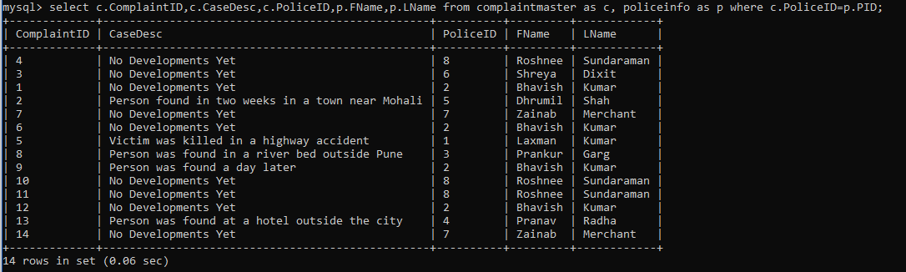

1. Whether the search operation is carried out or not?

>> select * from complaintmaster where CaseDesc!="No Developments Yet";

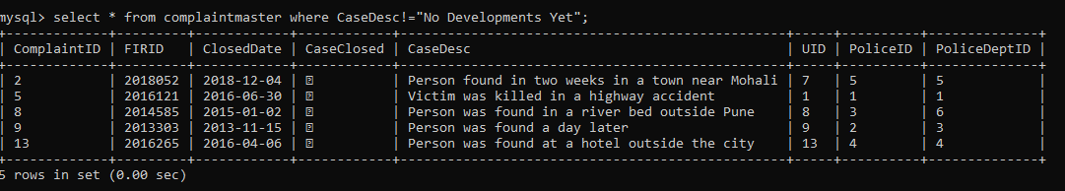

**Query for report generation**

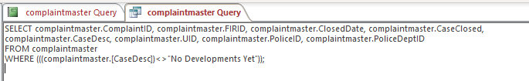

1. Which department has the largest pending missing complaint?

>> select c.PoliceDeptID,p.DepartmentName,count(c.PoliceDeptID) as "Count" from complaintmaster as c join policedepartment as p on c.PoliceDeptID=p.PDID where c.CaseClosed=0 group by c.PoliceDeptID order by count(c.PoliceDeptID) desc;

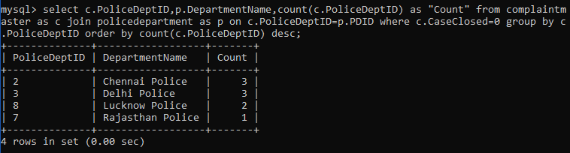

1. How many missing people are reported, by city and state?

>>select city,count(ComplaintID) from missingpersoninfo group by city;

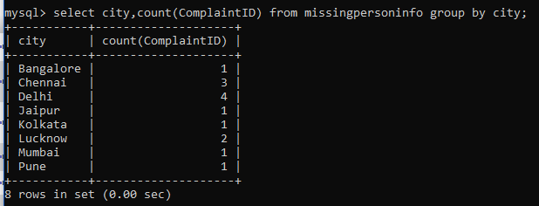

>>select state,count(ComplaintID) from missingpersoninfo group by state;

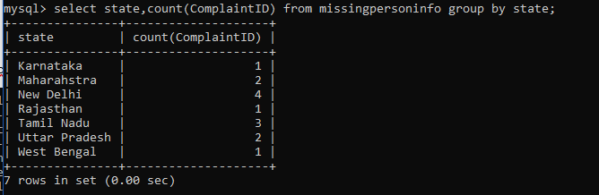

1. Which police department has the highest case solving rate?

>> select p.PDID,p.DepartmentName, ((select count(d.PoliceID) from policedepartment as t, complaintmaster as d where d.PoliceDeptID=t.PDID and d.PoliceDeptID=c.PoliceDeptID and d.CaseClosed=1 group by d.PoliceDeptID)/count(c.PoliceDeptID)) as “Case Solving Rate” from policedepartment as p, complaintmaster as c where c.PoliceDeptID=p.PDID group by c.PoliceDeptID

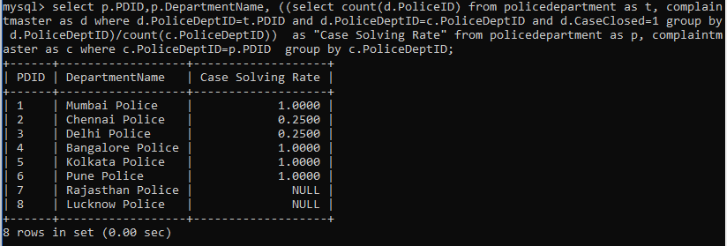

# Interface

## Forms

* **Police Designation From**

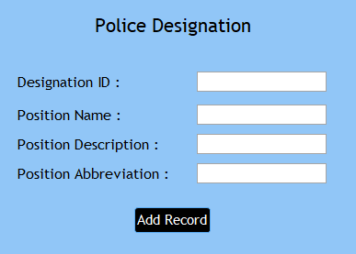

Figure 1: Add Record

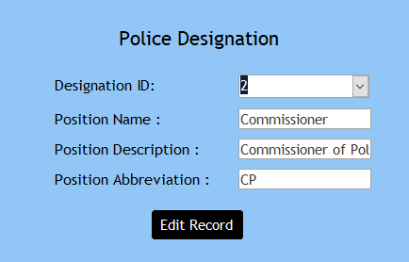

Figure 2: Edit Record

* **Police Department From**

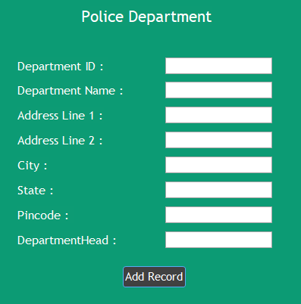

Figure 3: Add Record

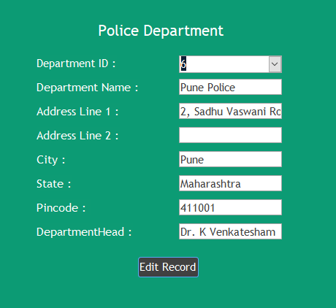

Figure 4: Edit Record

* **Police Information From**

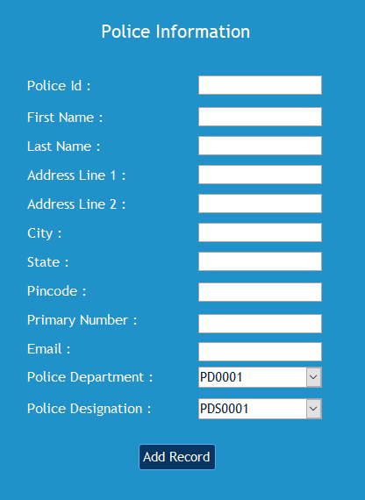

Figure 5: Add Record

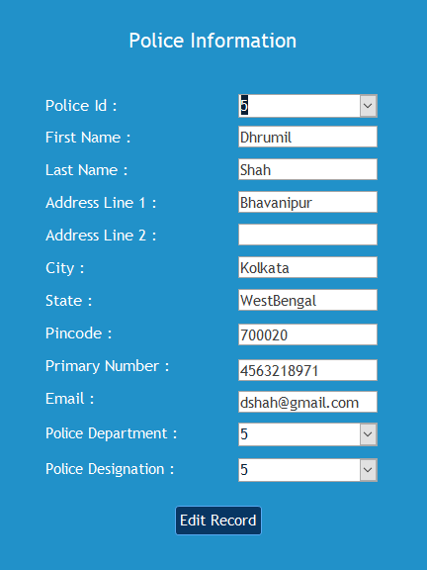

Figure 6: Edit Record

* **Registered User From**

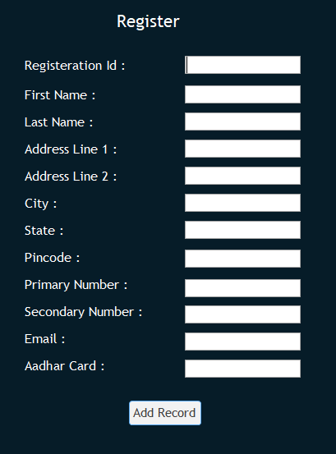

Figure 7: Add Record

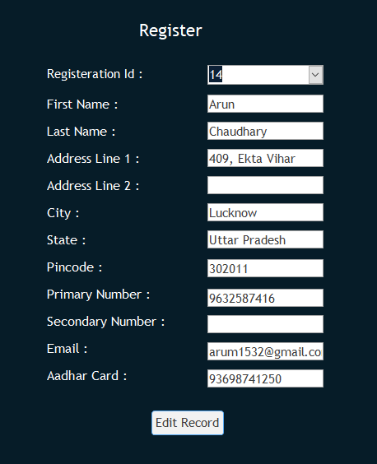

Figure 8: Edit Record

* **Mission Person’s Information From**

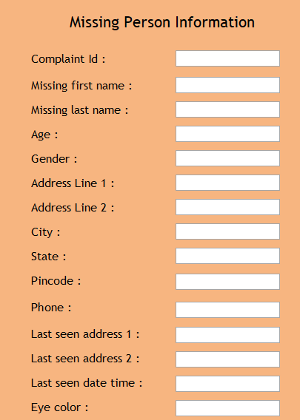

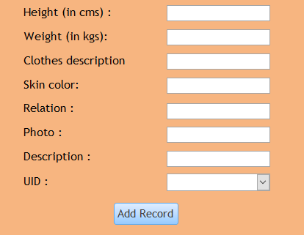

Figure 9:Add Record

* **Complaint Master Form**

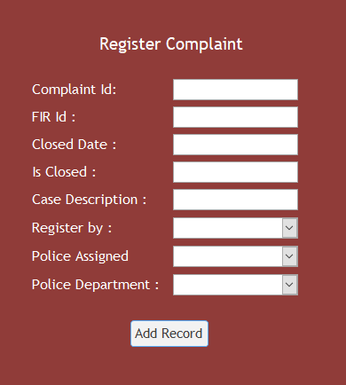

Figure 10: Add Record

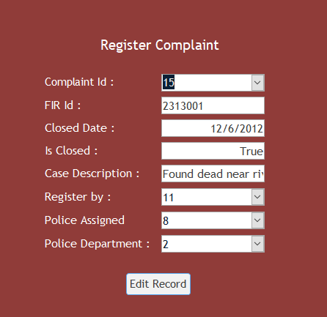

Figure 11: Edit Record

## Hybrid Mobile App

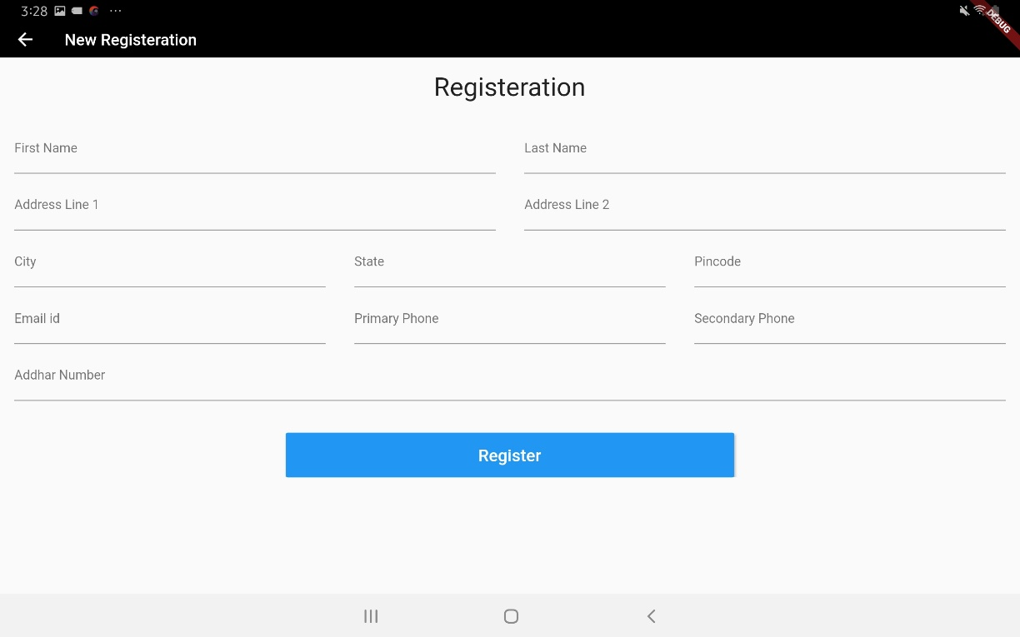Flutter is used to create hybrid mobile application. Flutter is a cross platform mobile application development framework. We have developed user interface as the application since the users are most likely to use portable devices. Due to unavailability to find API to establish communication between NOSQL database and MYSQL database we were unable to finish the project on time.

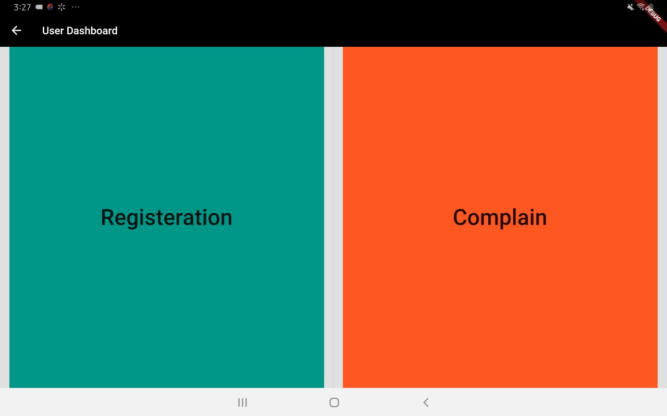

Figure 13: Dashboard

Figure 12: Registration Page

Figure 14: Complaint Page

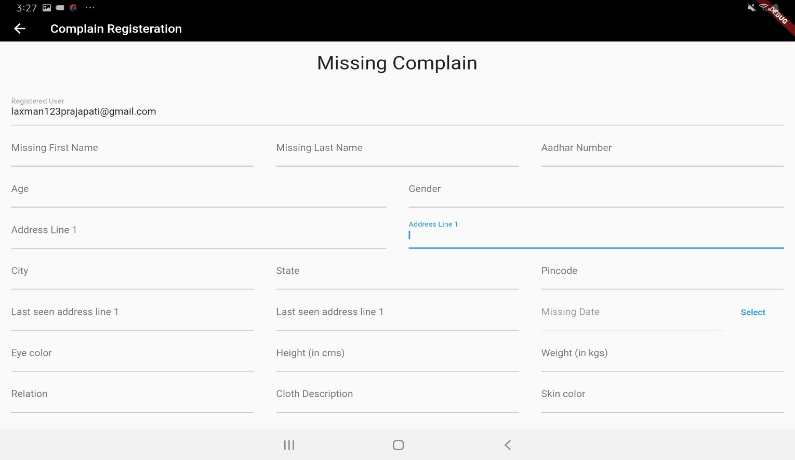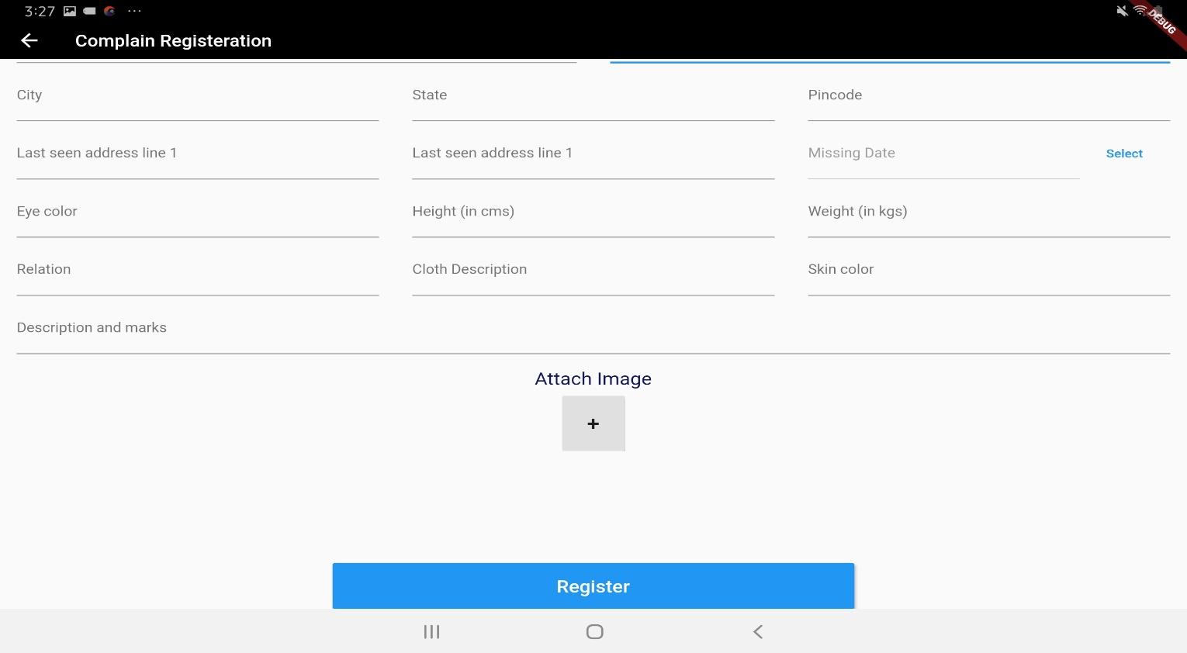

## Reports

* **Data Question 1: Which officer is assigned to the complaint filed?**

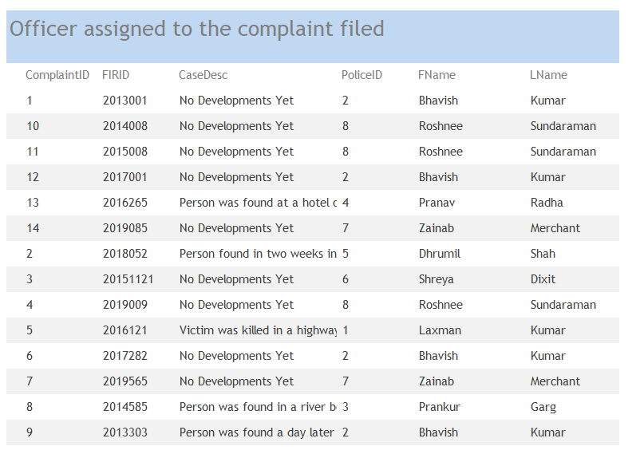

* **Data Question 2: Whether the search operation is carried out or not?**

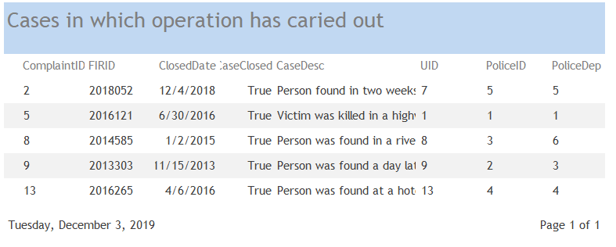

* **Data Question 3: Which officer is assigned to the complaint filed?**

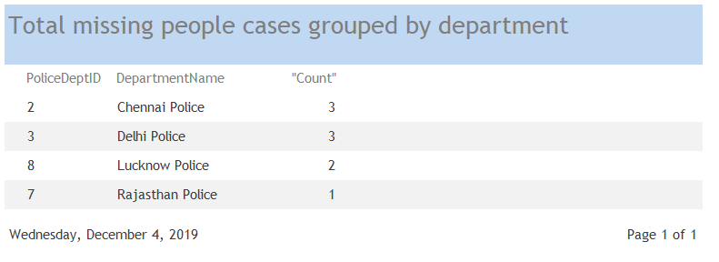

* **Data Question 4: How many missing people are reported, by city and state?**

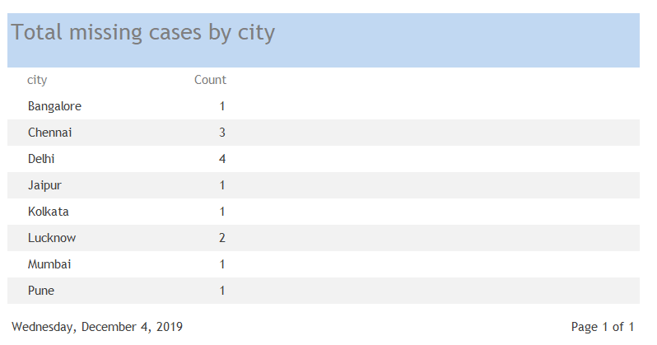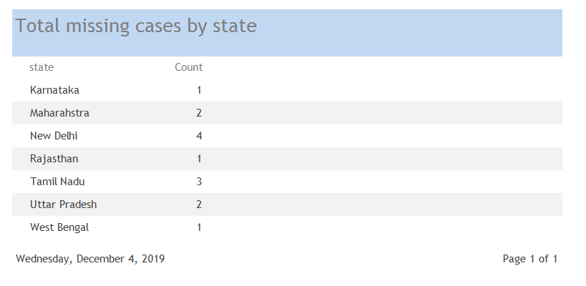

* **Data Question 5: Which police department has the highest case solving rate?**

